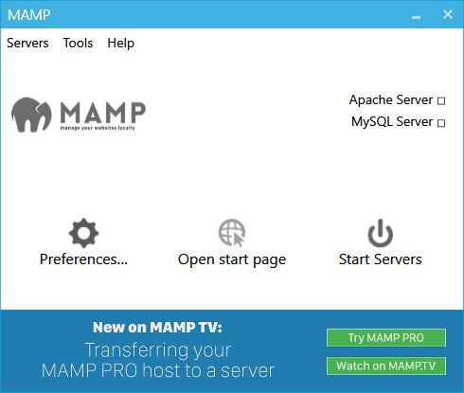

1. Open the MAMP Server Application, and click Preferences.

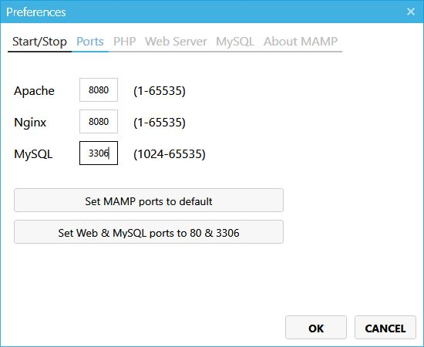

1. Change the value for your preferred ports number, then click OK.

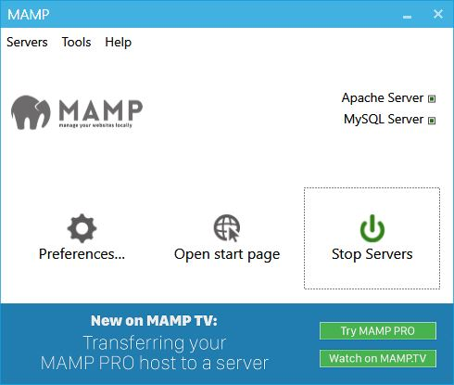

1. Click Start Server to run and use the MAMP server.

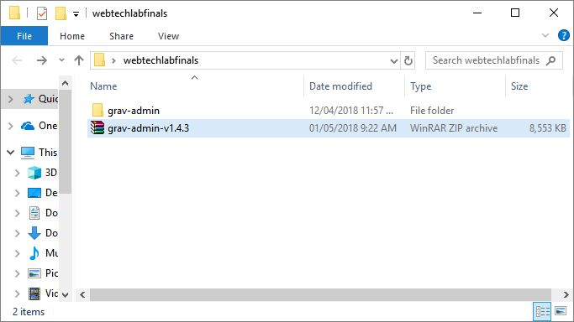

1. Extract downloaded framework “grav-admin-v1.4.3”.

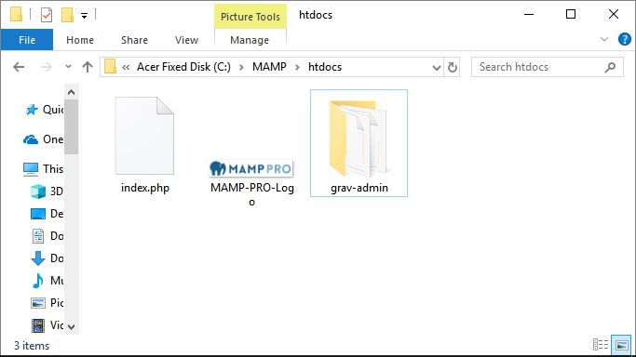

1. Copy the extracted folder “grav-admin” to C:\MAMP\htdocs\.

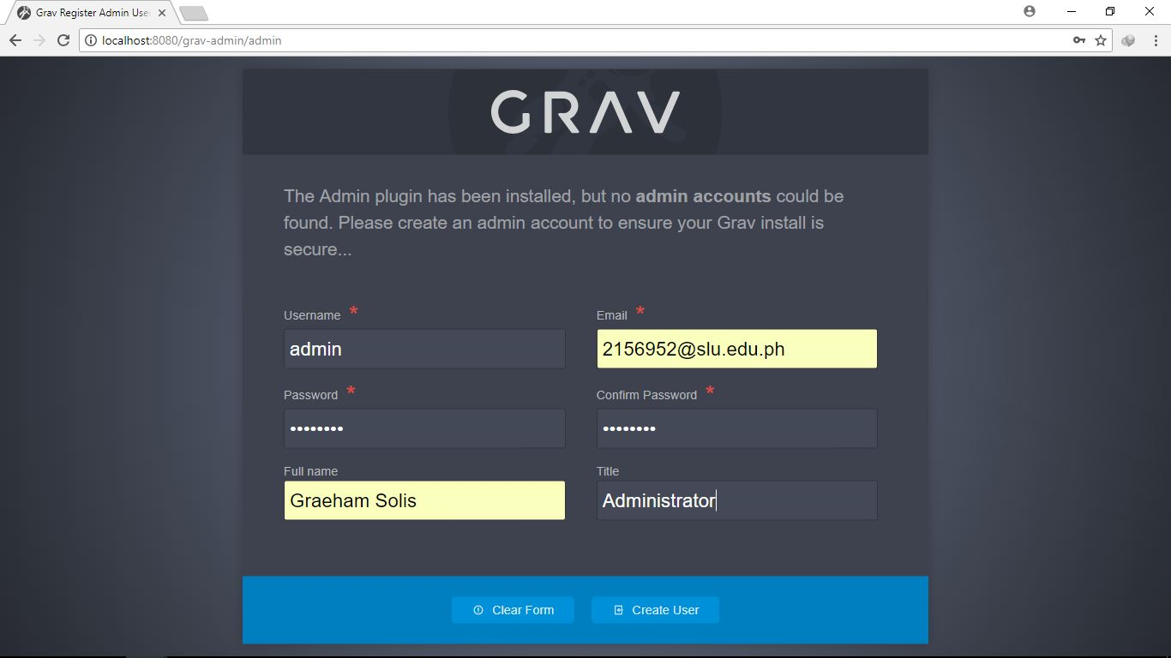

1. Open the browser and type localhost:8080(which is the preferred port no.)/grav-admin(the framework folder)/admin. Fill up required information and click Create User to create an admin account.

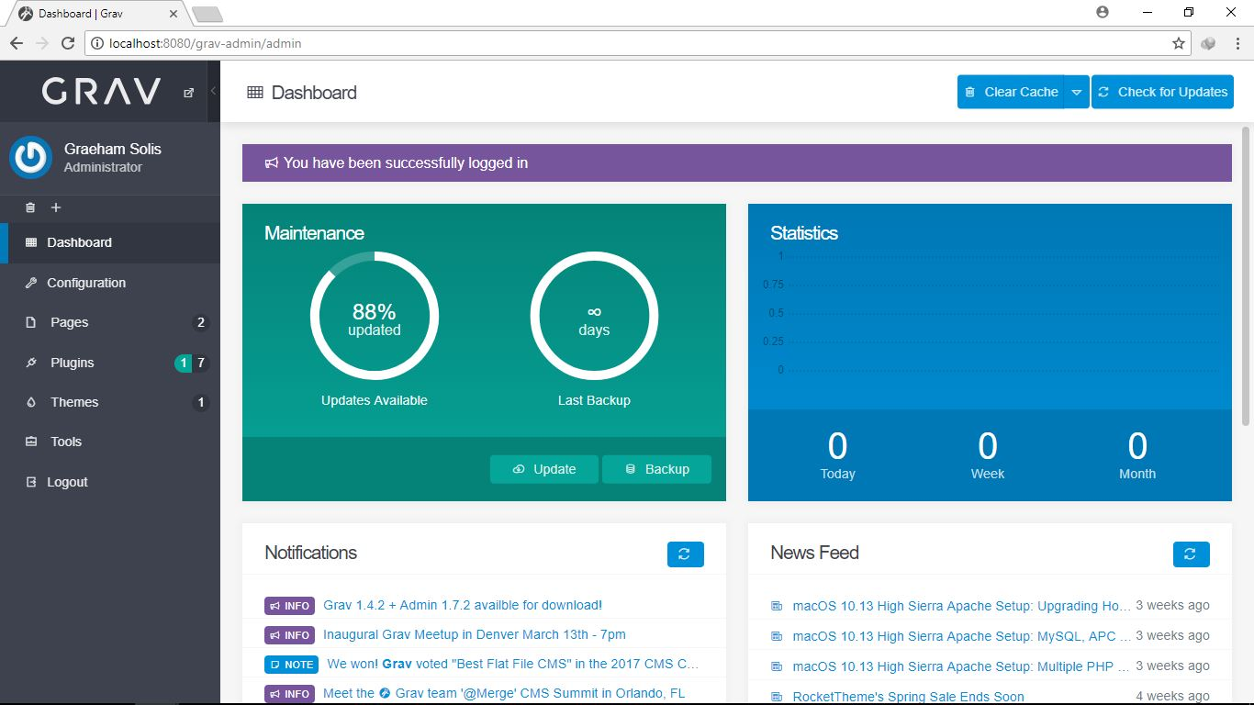

1. Then here.